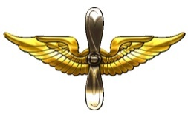  AVIATION BRANCH | ARMY FLIGHT  SURGEON | 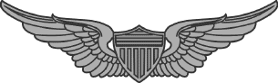  BASIC AVIATIOR |  | 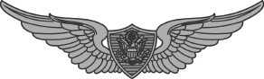  BASIC CREW WINGS
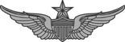  SENIOR AVIATOR WINGS | 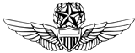  MASTER AVIATOR WINGS | 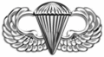  BASIC PARACHUTIST WING |  | 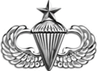  SENIOR PARACHUTIST WING
BASIC CREW (Pre-1947) | 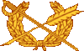  JAG CORP | MEDICAL SERVICE CORP |  | 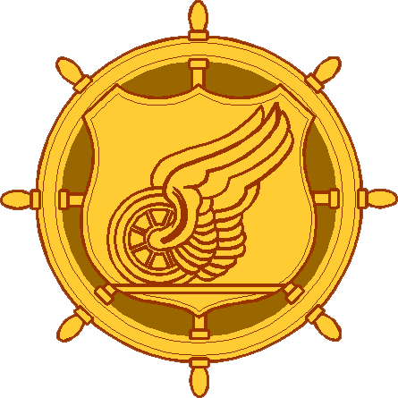  TRANSPORTATION CORP
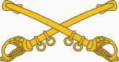  CAV CROSS SABERS | 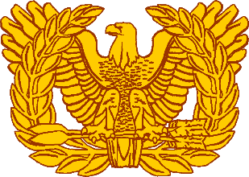  RISING EAGLE (WOI) | 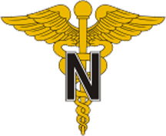  ARMY NURSE CORP |  | 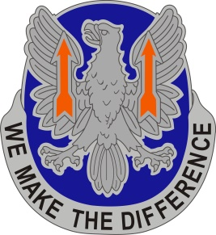  11TH AVN REGIMENT
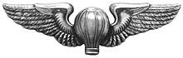  LIASION PILOT | 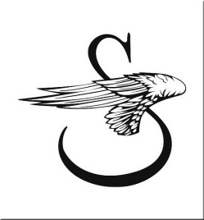  SIKORSKY | 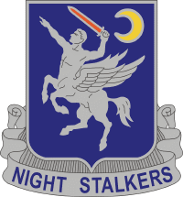  NIGHTSTALKER 160TH
3RD RANGER BATTALION | 40 CAB PHOENIX | TCM RECON/ATTACK |  | TRADOC(Lift)  cap.manager
BOEING | BRUNSON, WILKERSON, BOWDEN AND ASSOCIATES P.C. | DALEVILLE AL JROTC WARHAWK |  | FIXED WING PROJECT OFFICE
NATTIE “B” | NAVIGATOR | PEO AVIATION |  | L3 Army Fleet Support
4TH/152ND | PINNACLE SOLUTIONS/HUNTSVILLE | AAAA FL CHPT

